**Scenario: Launch instagram**

**Step: Launch "instagram" WebPage - PASS**

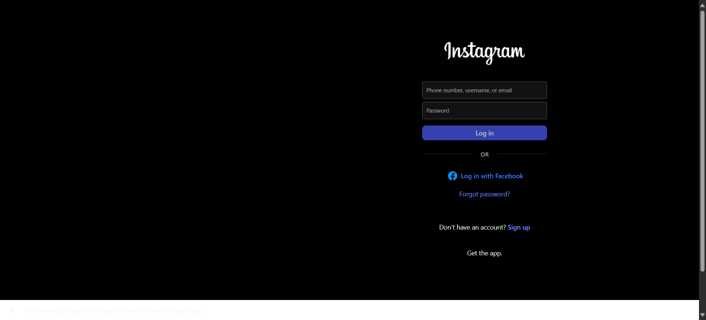

**Step: Enter UserName "subb" into "Username1" textbox at "LoginPage" page - FAIL**

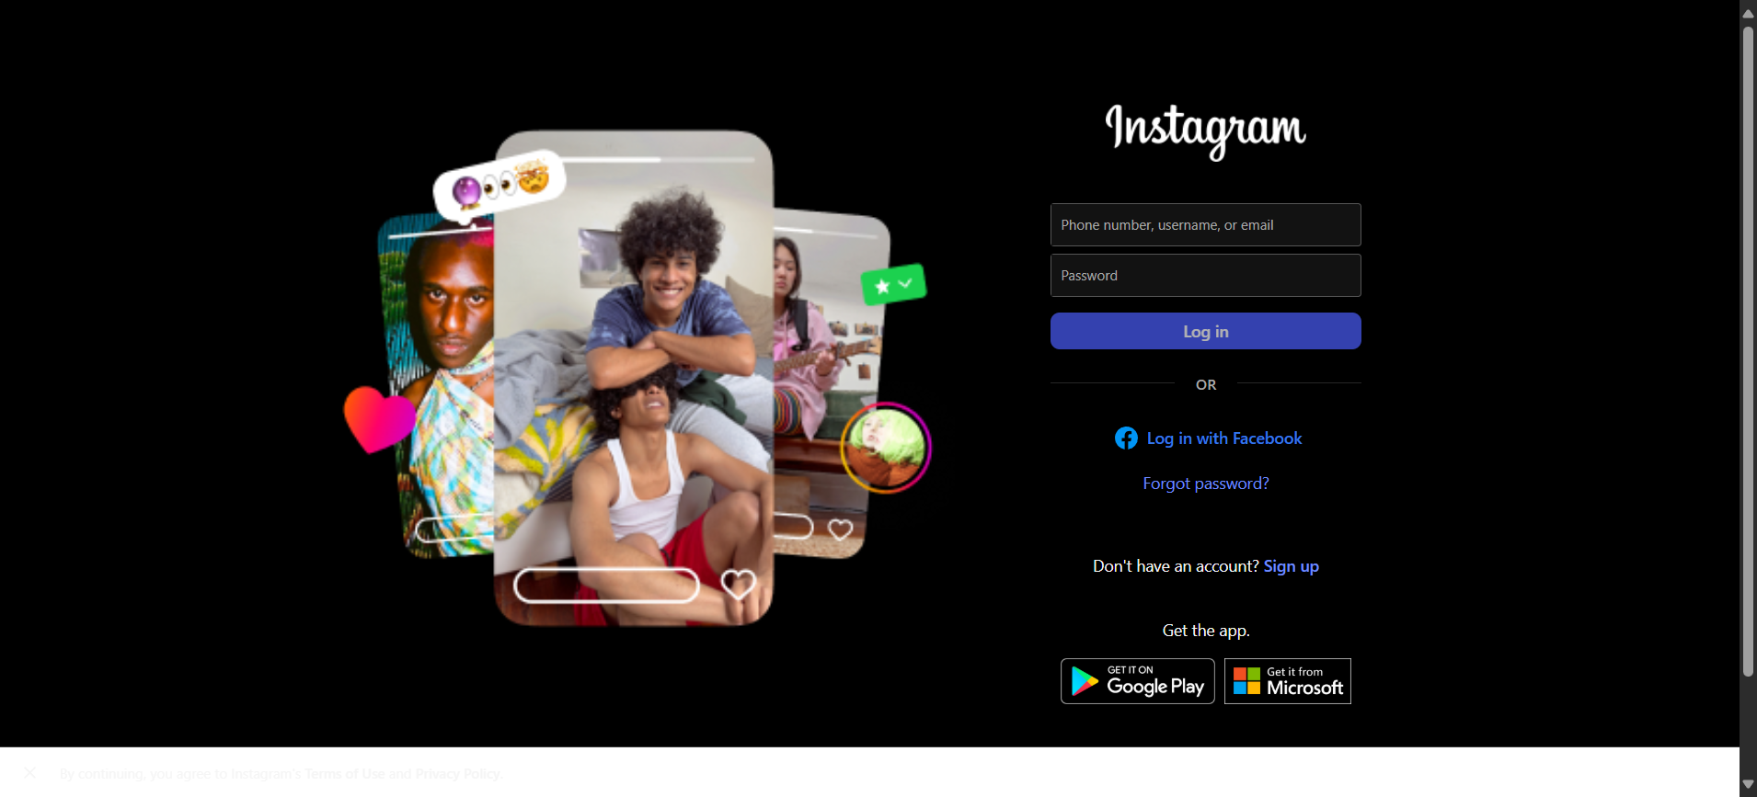

**Execution Summary:  
Total Steps: 2  
Passed: 1  
Failed: 1**

**Step: Launch "instagram" WebPage - PASS**



**Step: Enter UserName "arise" into "Username1" textbox at "LoginPage" page - PASS**

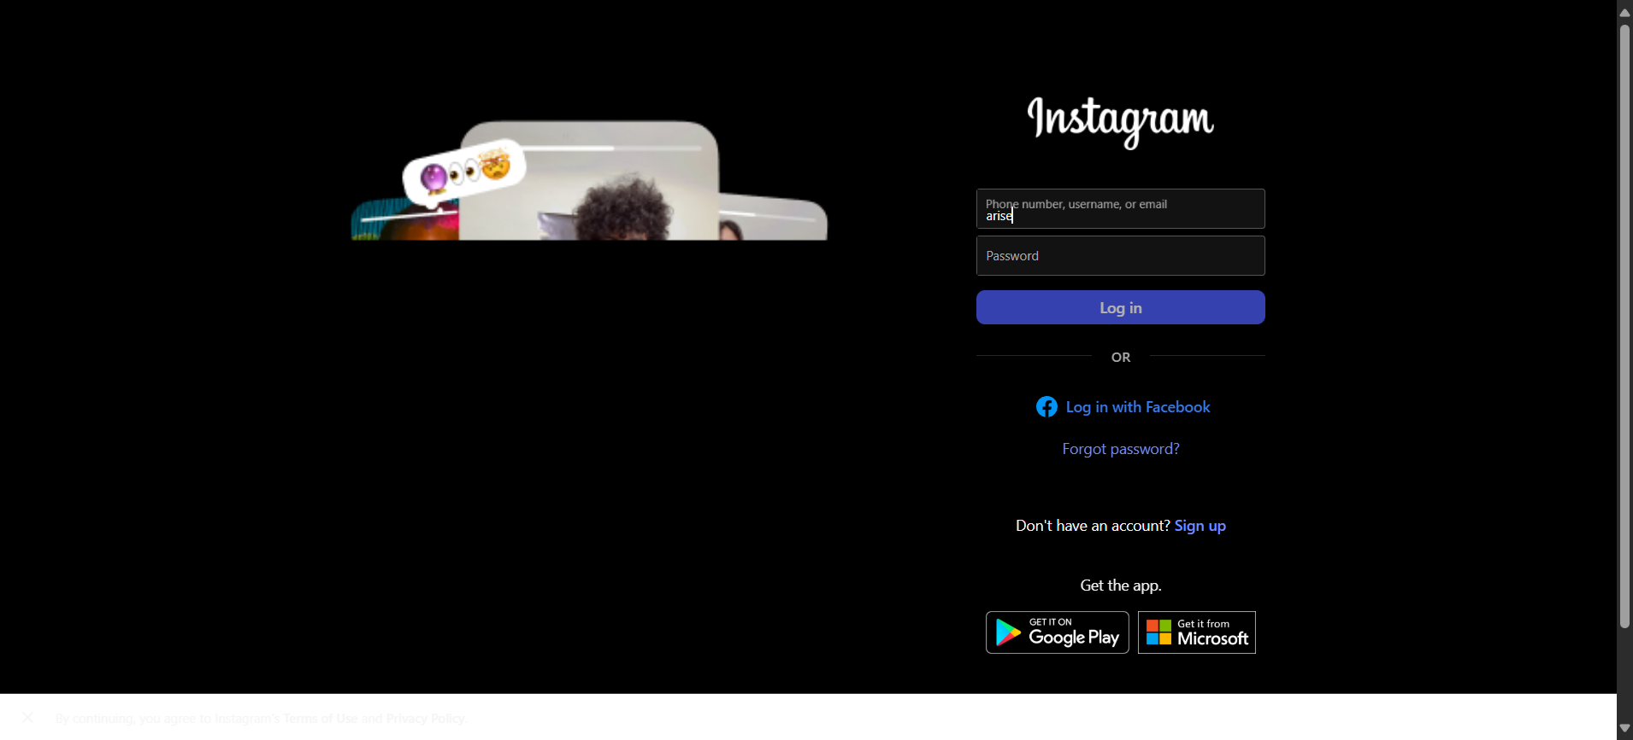

**Step: Enter Password "pass_b" into "Password2" textbox at "LoginPage" page - PASS**

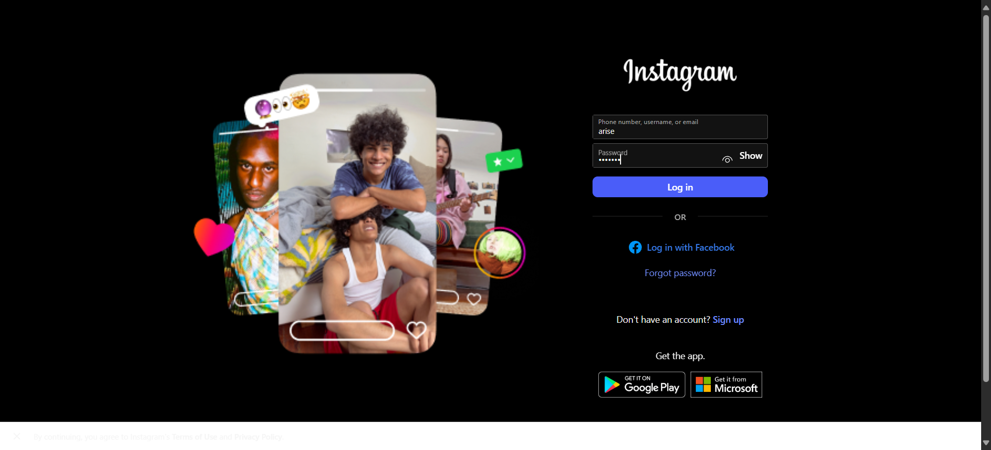

**Step: Click "login_button1" element at "LoginPage" page - PASS**

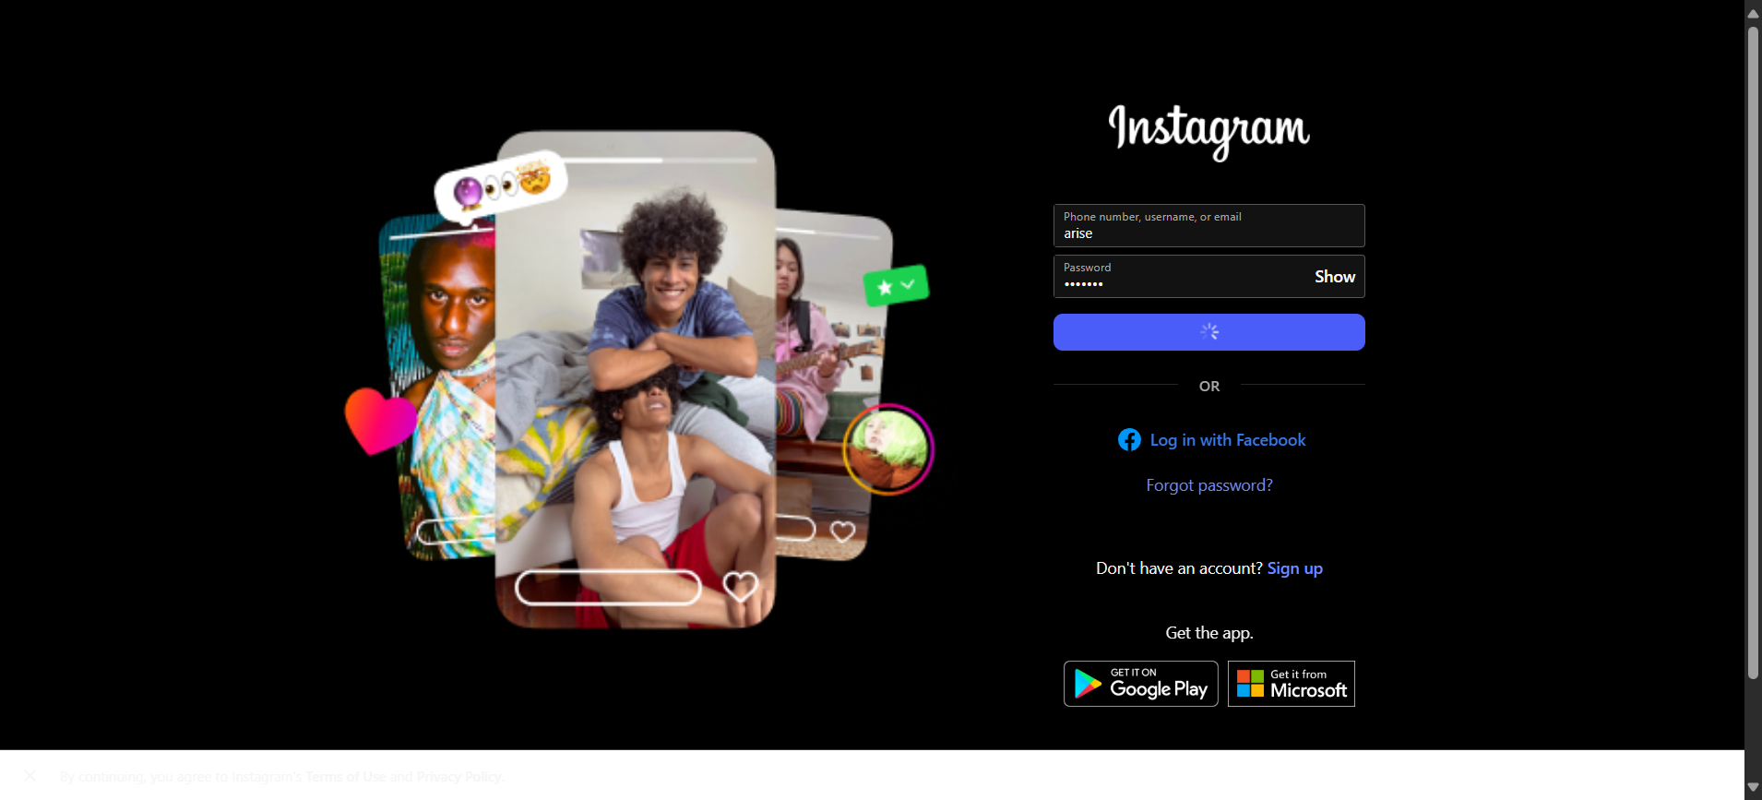

**Execution Summary:  
Total Steps: 6  
Passed: 5  
Failed: 1**

**Scenario: Launch Automation_Practice_Url**

**Step: Launch "Automation_Practice_Url" WebPage - PASS**

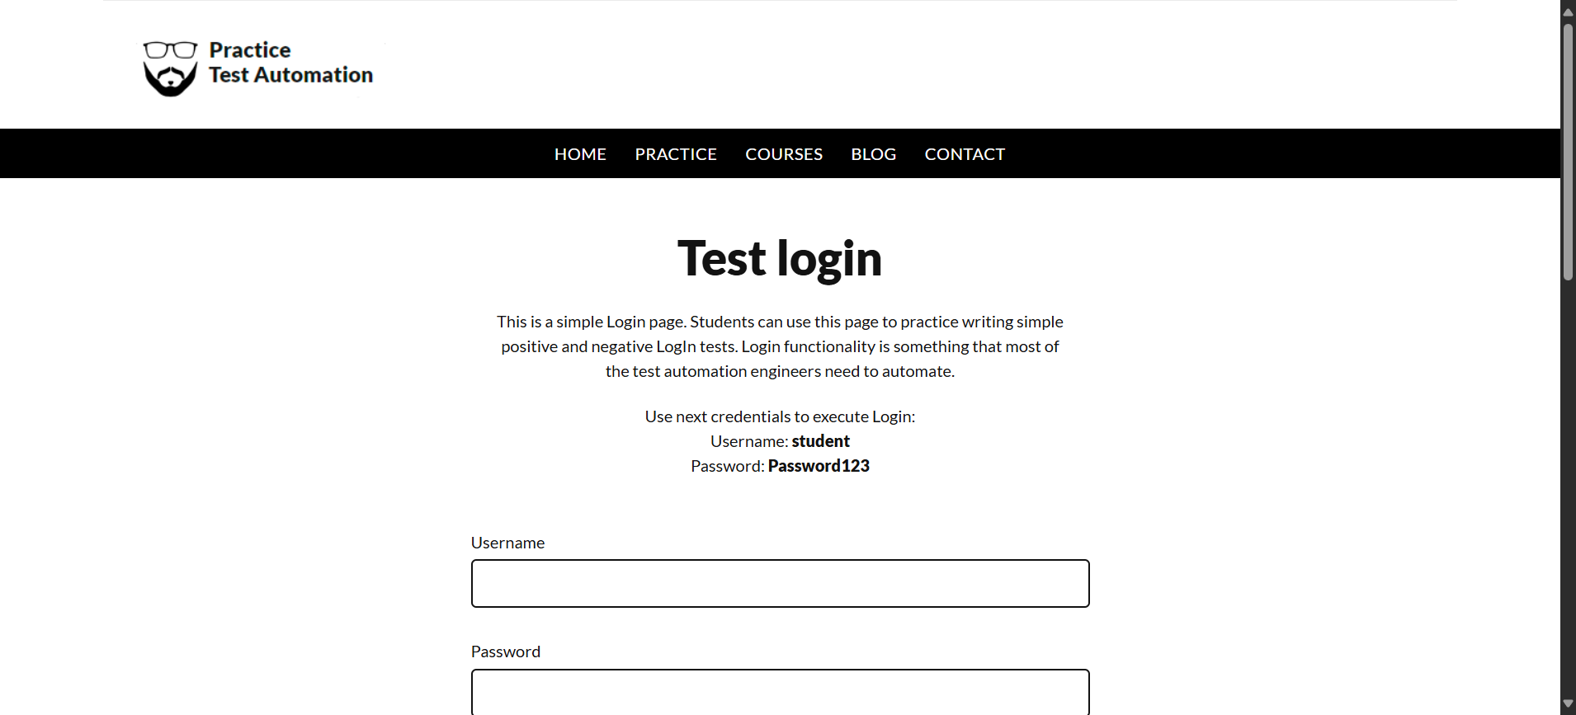

**Step: Enter UserName "username" into "Username" textbox at "LoginPage" page - PASS**

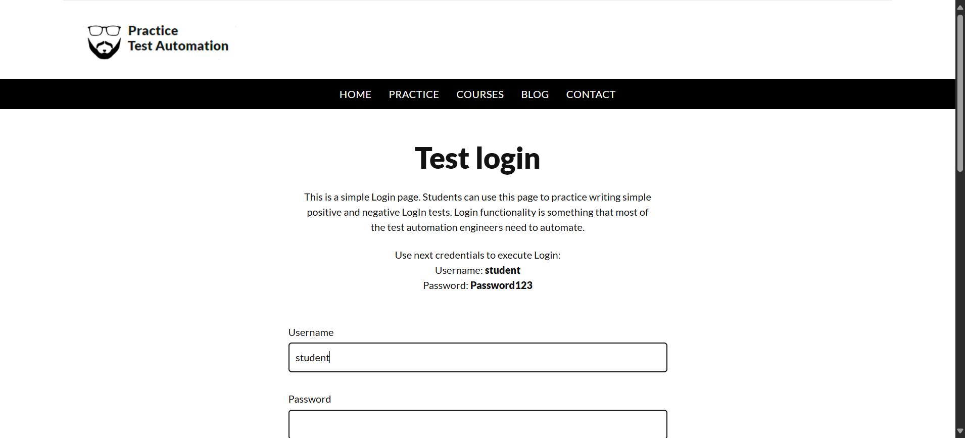

**Step: Enter Password "password" into "Password" textbox at "LoginPage" page - PASS**

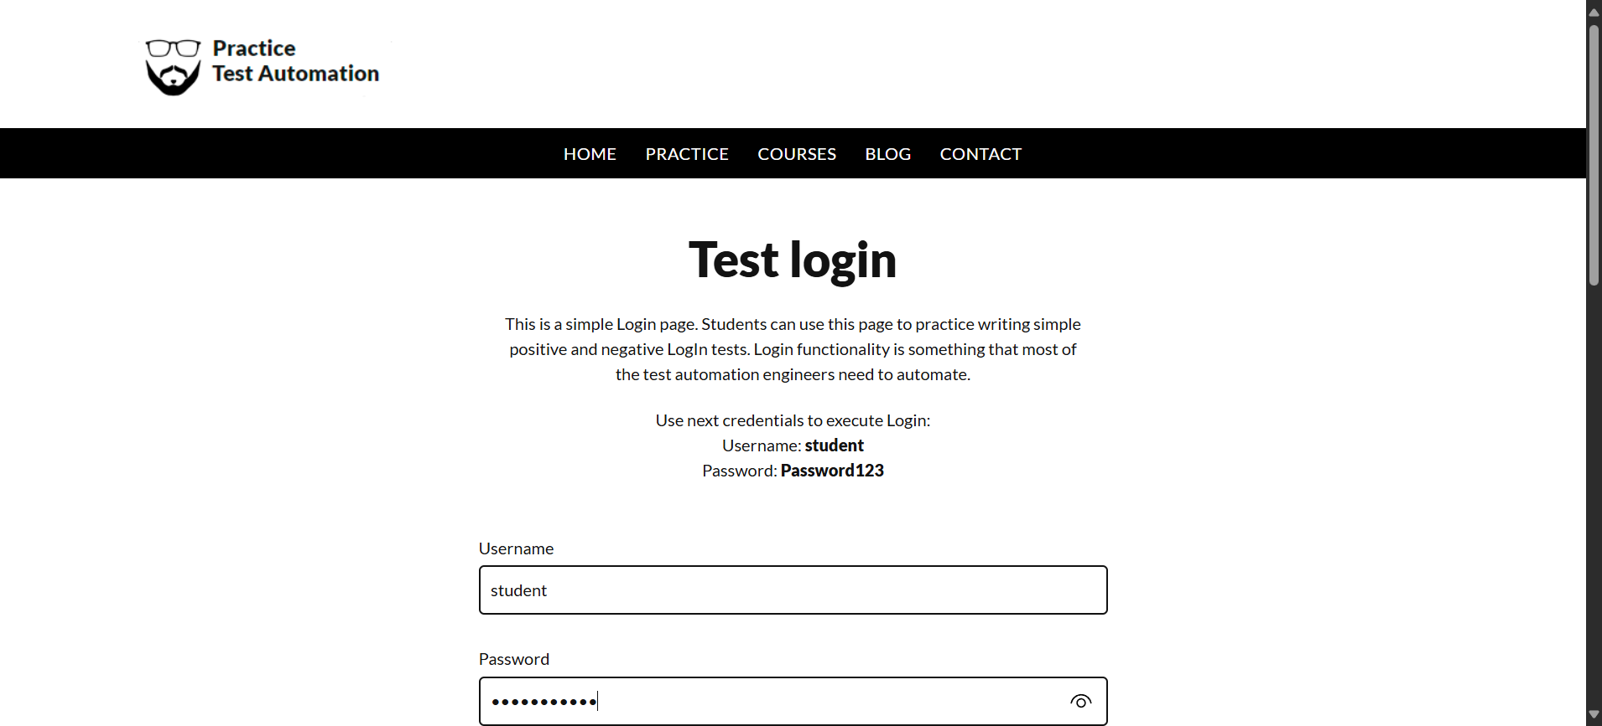

**Step: Click "login_button" element at "LoginPage" page - PASS**

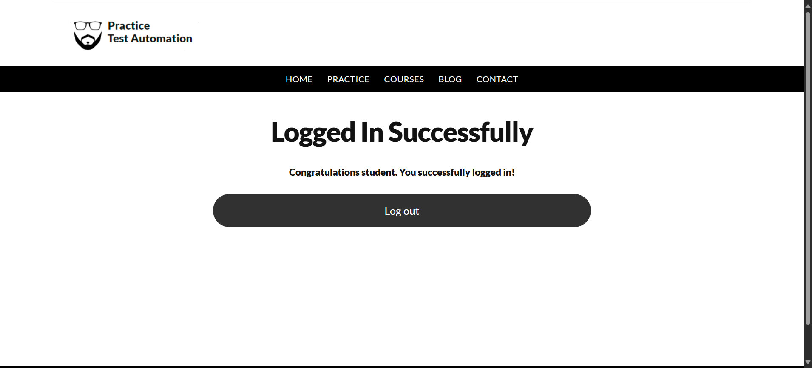

**Execution Summary:  
Total Steps: 10  
Passed: 9  
Failed: 1**